**SPH3U: 1.1 Distance, Position, and Displacement**

1. **What is kinematics?**

|  |  |
| --- | --- |
| Kinematics: |  |
| distance |  |

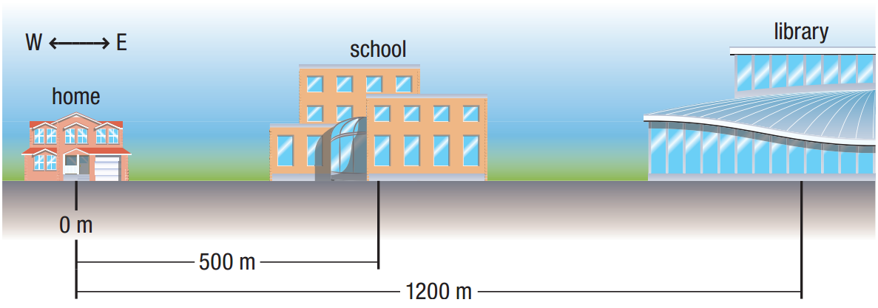

In the figure above, how far will you have traveled if you:

1. walk directly from home to your school?
2. walk from your school to the library, then return home?
3. **Position and displacement**

|  |  |
| --- | --- |
| Scalar: |  |
| Vector: |  |
| position |  |
| reference point |  |
| displacement |  |
| delta (∆) |  |

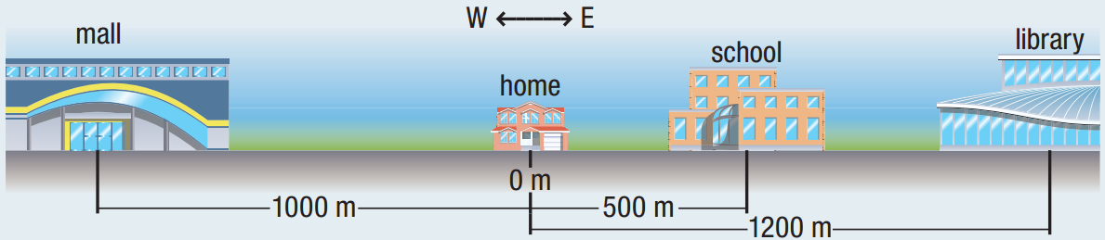

In the figure above, what is:

1. the position of the school, with home as a reference point?
2. the position of the school, with the library as a reference point?

Imagine that you walk from home to school in a straight-line route. What is your displacement? Use your home as a reference point.

What is your displacement if you walk from your school to the library?

One night after working at the library, you decide to go to the mall. What is your total displacement when walking from the library to the mall?

A dog is practising for her agility competition. She leaves her trainer and runs 80 m due west to pick up a ball. She then carries the ball 27 m due east and drops it into a bucket. What is the dog’s total displacement?

1. **Vector scale diagrams**

|  |  |
| --- | --- |
| Vector scale diagrams: |  |
| directed line segment |  |
| tip and tail |  |
| adding vectors |  |

Add the two displacements $∆{\overset{⃑}{d}}_{1}$ = 700 m [W] and $∆{\overset{⃑}{d}}_{2}$ = 500 m [W] by drawing a vector scale diagram.

Imagine that you are going to visit your friend. Before you get there, you decide to stop at the variety store. If you walk 200 m [N] from your home to the store, and then travel 600 m [S] to your friend’s house, what is your total displacement?

**Homework:** page 13: #1-6